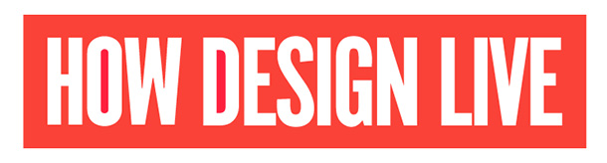
Hi [Manager Name],
I would like to attend HOW Design Live, taking place June 5-7, 2023.
HOW Design Live is a professional conference focused on the business of design. It is where creative professionals in all disciplines converge to learn from the brightest minds in the industry as well as creative thinkers in other fields. Past and present speakers include Elizabeth Gilbert, Malcolm Gladwell, Brene Brown, Debbie Millman, Stephen Gates, Chip Kidd, Natasha Jen and many more.
I will be able to discover new ideas, create meaningful connections, learn new skills, and experience hands-on learning in workshops and master classes that I can apply in my day-to-day work.
HOW Design Live offers both the creative inspiration to reignite my passion for design, plus the tactical, take-home information I need to achieve and succeed in my career. It offers practical, technical sessions that address the design challenges I face every day and enable me to increase my level of productivity.
This is the event for designers and creative professionals and I need to be there.
Here are the top five benefits to our company if I attend:
- Sharpen my skills. I’ll learn from industry-leading speakers across multiple tracks. I’ll learn how to think strategically, develop design solutions that meet the company’s current challenges, engage with clients and effectively communicate with our customer base to grow our business.

- Get the inside look. I’ll hear from a broad spectrum of successful brands such as PepsiCo, Staples, Etsy, Facebook, Adobe, Taco Bell and many others. I’ll learn how these companies leverage branding, communication and design for bottom-line growth—and how our organization can do the same.

- Improve collaboration and workflow. At HOW Design Live, I’ll attend sessions on running better meetings, working smoothly with colleagues (both inside and out) and handling feedback and criticism.

- Discover. In the virtual Exhibit Hall, I’ll be able to meet new vendors with the latest solutions (and maybe even better pricing), including innovative suppliers of printing, paper, stock imagery, software and other tools of the design trade.
- Networking. HOW Design Live is one of the premier gatherings of creative professionals. I’ll be able to network with creative peers from all over the world who are also passionate about the business of design. In every session and in every conversation, I’ll be collecting new ideas for working smarter—ideas I’ll bring back to our team the very next day.
HOW Design Live is integral to my professional development. I will bring back new ideas, best practices, and solutions that we can implement right away. Additionally, I will develop an overview of what I’ve learned and actionable takeaways for the team so that we can work together to move the department and [insert organization name] forward.
I hope you will consider my request and grant me approval to attend.
Thank you for your consideration.
Sincerely,
[Your Name]

